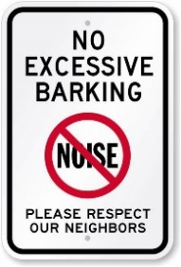

**TRASH COMPACTOR**

The compactor runs on its own. Every 3rd time the door is closed, the compactor will beep and proceed to do its job.

Please do not press any buttons. If the compactor is full please call the leasing office.

***Our Online Portal***

Our Online Portal, Active Building/ RealPage is active. Please be sure to sign-up. You can see your account, pay your rent/water/sewer etc. and put in a Service Request.

You can still pay by check/money order in the Leasing office.

**PETS**

Residents are responsible for their animal’s actions at all times.

The animal must not disturb the neighbors or other residents, regardless of whether the animal is inside or outside.

**PARKING**

As our community continues to grow, we want to make sure all residents have enough parking throughout the neighborhood.

Vehicles with no tags, expired tags/registration, or disabled vehicles are prohibited from the property, we will be towing any/all vehicles that are in violation of the lease.

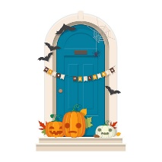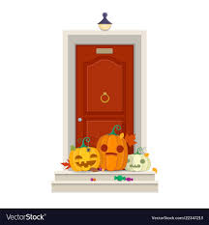

Trick or Treat

When: Thursday, Oct 31st

Where: Leasing Office

Grab a bag of treats before you go out Trick or Treating

**10/1-10/31: The Leasing Office will have *In Memory and In Honor* cards available for all donations given to the VBCF. All cards will be put on display on the windows of our Leasing office.**

**10/16 from 5:30PM to 6:30PM: Pumpkin Patch for kids and adults!!**

**Chance to win prizes! Sponsored by Terrace Greene Apartments**

**1 pumpkin = 1 raffle ticket = 1 entry into two different raffles.**

**Prize will be a TG $20 gift card & a Grand Prize $30 w/ snack basket**

**Raffle WINNER announced on October 27th!**

**Terrace Greene will match all donations!!**

**Make sure you come out and support the Virginia Breast Cancer Foundation!**

Smok Shak

Thursday, Oct 18th

4:30p-7:30p

Premier Baking Co.

Thursday, Oct 11th

4:30p-7:30p

**Terrace Greene will be partnering with the Virginia Breast Cancer Foundation for the entire month of October!!!**

**Save The Pumpkins**

Let’s see your creativity TG!!

Submit a photo of your Halloween door decorations for a chance to win a spooky prize!

All photos must be submitted to leasing@terracegreene.com by 10/25

WINNER announced 10/30!!!

**Halloween Door Decorating Contest**